**Section 3. Recursion Etudes**

*Section materials curated by Neel Kishnani, drawing upon materials from previous quarters.*

This week’s section exercises explore the ins and outs of content from week 3 – thinking recursively! These problems will help in gaining familiarity with recursive problem-solving.

📦 [Starter code](https://web.stanford.edu/class/cs106b/section/section3/section3_starter.zip)

**1) Recursion Tracing**

*Topics: Recursion call and return, Tracing*

Below are a collection of recursive functions, along with an initial call to each of those functions. Determine what value is returned from each function. As a note, some of these functions contain bugs (or at least, highly misleading code structures) that make them not behave in the way you might initially expect, and it's worth making a note, for each function, what *specifically* that function does that's Cruel and Unusual.

int bishkek(int n) {

**if** (n <= 2) {

**return** n;

}

int result = 137;

bishkek(n - 1);

result++;

bishkek(n - 2);

result++;

bishkek(n - 3);

result++;

**return** result;

}

*// (1) Determine what this outputs!*

cout << bishkek (8) << endl;

int batken(**const** Vector<int>& v) {

**if** (v.isEmpty()) {

**return** -1;

}

int total = 0;

**for** (int i = 1; i < v.size(); i++) {

total += v[i];

**return** batken(v.subList(i));

}

**return** total;

}

*// (2) Determine what this outputs!*

cout << batken({1, 2, 3, 4}) << endl;

[Solution](https://web.stanford.edu/class/cs106b/section/section3/#solution-collapse-1)

**2) Splitting The Bill**

*Topic: Recursion, Combinations, Sets*

You’ve gone out for coffees with a bunch of your friends and the waiter has just brought back the bill. How should you pay for it? One option would be to draw straws and have the loser pay for the whole thing. Another option would be to have everyone pay evenly. A third option would be to have everyone pay for just what they ordered. And then there are a ton of other options that we haven’t even listed here!

Your task is to write a function

void listPossiblePayments(int total, **const** Set<string>& people);

that takes as input a total amount of money to pay (in dollars) and a set of all the people who ordered something, then lists off every possible way you could split the bill, assuming everyone pays a whole number of dollars. For example, if the bill was $4 and there were three people at the lunch (call them A, B, and C), your function might list off these options:

A: $4, B: $0, C: $0

A: $3, B: $1, C: $0

A: $3, B: $0, C: $1

A: $2, B: $2, C: $0

A: $2, B: $1, C: $1

A: $2, B: $0, C: $1

…

A: $0, B: $1, C: $3

A: $0, B: $0, C: $4

Some notes on this problem:

* The total amount owed will always be nonnegative. If the total owed is negative, you should use the **error()** function to report an error.
* There is always at least one person in the set of people. If not, you should report an error.
* You can list off the possible payment options in any order that you'd like. Just don't list the same option twice.
* The output you produce should indicate which person pays which amount, but aside from that it doesn't have to exactly match the format listed above. Anything that correctly reports the payment amounts will get the job done.

[Solution](https://web.stanford.edu/class/cs106b/section/section3/#solution-collapse-2)

**3) Change We Can Believe In**

*Topics: Sets, Recursion, Optimization*

In the US, as is the case in most countries, the best way to give change for any total is to use a *greedy strategy* – find the highest-denomination coin that’s less than the total amount, give one of those coins, and repeat. For example, to pay someone 97¢ in the US in cash, the best strategy would be to:

* give a half dollar (50¢ given, 47¢ remain), then
* give a quarter (75¢ given, 22¢ remain), then
* give a dime (85¢ given, 12¢ remain), then
* give a dime (95¢ given, 2¢ remain), then
* give a penny (96¢ given, 1¢ remain), then
* give another penny (97¢ given, 0¢ remain).

This uses six total coins, and there’s no way to use fewer coins to achieve the same total.

However, it’s possible to come up with coin systems where this greedy strategy doesn’t always use the fewest number of coins. For example, in the tiny country of Recursia, the residents have decided to use the denominations 1¢, 12¢, 14¢, and 63¢, for some strange reason. So suppose you need to give back 24¢ in change. The best way to do this would be to give back two 12¢ coins. However, with the greedy strategy of always picking the highest-denomination coin that’s less than the total, you’d pick a 14¢ coin and ten 1¢ coins for a total of fifteen coins. That’s pretty bad!

Your task is to write a function

int fewestCoinsFor(int cents, **const** Set<int>& coins);

that takes as input a number of cents and a **Set<int>** indicating the different denominations of coins used in a country, then returns the minimum number of coins required to make change for that total. In the case of US coins, this should always return the same number as the greedy approach, but in general it might return a lot fewer! Once you’ve written this function, discuss with the group whether memoization (described in the handout for Assignment 3) would be appropriate here. If so, go and add memoization to this function. If not, explain why not.

And here’s a question to ponder: given a group of coins, how would you determine whether the greedy algorithm is always optimal for those coins?

You can assume that the set of coins always contains a 1¢ coin, so you never need to worry about the case where it’s simply not possible to make change for some total. You can also assume that there are no coins worth exactly 0¢ or a negative number of cents, since that makes no sense. (No pun intended.) Finally, you can assume that the number of cents to make change for is nonnegative.

[Solution](https://web.stanford.edu/class/cs106b/section/section3/#solution-collapse-3)

**4) Ordering Prerequisites**

*Topics: Maps, Vectors, Permutations, Recursion*

Imagine you have some collection of tasks that need to be done. Some of those tasks might depend on one another. For example, you might be navigating the CS Core, shown here:

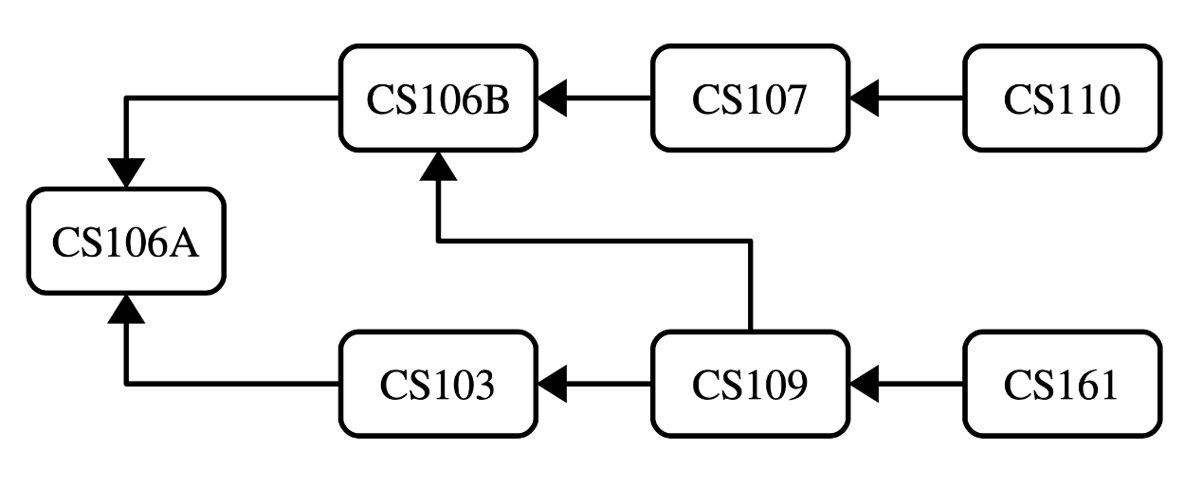

Here, the arrows indicate prerequisites. CS106B has CS106A as a prerequisite, CS110 has CS107 as a prerequisite, CS109 has both CS106B and CS103 as prerequisites, and CS106A has no prerequisites. Assuming you can only take one CS class per quarter, what possible orderings are there for these classes that don’t violate any prerequisites? Your task is to write a function

void listLegalOrderingsOf(**const** Map<string, Set<string>>& prereqs);

that takes as input a Map representing the prerequisite structure, then lists all possible orders in which you could complete those tasks without violating the prerequisites. The prereqs map is structured so that each key is a task and each value is the set of that task’s immediate prerequisites. For example, the CS Core would be represented by the following map:

"CS103" : { "CS106A" }

"CS106A" : { }

"CS106B" : { "CS106A" }

"CS107" : { "CS106B" }

"CS109" : { "CS103", "CS106B" }

"CS110" : { "CS107" }

"CS161" : { "CS109" }

Given this structure, your function would then print out all the following:

CS106A, CS106B, CS107, CS110, CS103, CS109, CS161

CS106A, CS103, CS106B, CS109, CS161, CS107, CS110

CS106A, CS106B, CS107, CS103, CS109, CS161, CS110

(... many, many more ...)

Some notes on this problem:

* Every task will be present in the Map. A task with no prerequisites will be represented as a key whose value is an empty Set, as is the case for CS106A in the above example.
* Your function must not list off the same ordering twice.
* Your function must not work by simply generating all possible permutations of the tasks and then printing out just the ones that obey all the constraints. That would just be too inefficient.
* Your output doesn’t have to exactly match our format. List off the orderings in whatever format you’d like. In case it helps, you can directly print a Map, Set, Vector, or Lexicon to cout.
* It’s entirely possible that the set of tasks you’re given can’t actually be ordered. For example, if the task "Learn Recursion" depends on "Learn Recursion", then no matter how you order things the prerequisites won’t be satisfied. In that case, your function should just not print any- thing at all. Chances are, you won’t need to do anything fancy to make this work. It’ll just fall out naturally.

[Solution](https://web.stanford.edu/class/cs106b/section/section3/#solution-collapse-4)

There are a number of different ways to do this. The key insight we used in this solution is that at each point in time, we can choose any task to do as the next task provided that we’ve already handled all its prerequisites. That gives us some number of things to try at each step, so we’ll try doing each of them first.

void listLegalOrderingsRec(**const** Map<string, Set<string>>& prereqs,

**const** Vector<string>& tasksPerformed,

**const** Set<string>& tasksRemaining) {

*/* Base case: If there are no remaining tasks, output this as one possible*

*\* option.*

*\*/*

**if** (tasksRemaining.isEmpty()) {

cout << tasksPerformed << endl;

**return**;

}

*/* Otherwise, try adding in as a possible next task all tasks that have had*

*\* all their prerequisites satisfied.*

*\*/*

*/* For convenience, convert the vector of tasks into a set. */*

Set<string> tasksDone;

**for** (string task: tasksPerformed) {

tasksDone += task;

}

**for** (string task: remainingTasks) {

**if** (prereqs[task].isSubsetOf(tasksDone)) {

Vector<string> newTasks = tasksPerformed;

newTasks += task;

listLegalOrderingsRec(prereqs, newTasks, tasksRemaining – task);

}

}

}

void listLegalOrderingsOf(**const** Map<string, Set<string>>& prereqs) {

Set<string> tasks;

**for** (string task: prereqs) {

tasks.add(task);

}

listLegalOrderingsRec(prereqs, {}, tasks);

}